**The Unpredictability of Uninitialized Variables**

## *Vishal Verma*

## *Computer Science Engineering, Bachelor of Technology.*

## Abstract

Unpredictable behavior that can lead to hard-to-detect bugs and security vulnerabilities. This paper explores the reasons behind the randomness observed in uninitialized variable values, focusing on how memory allocation, compiler optimizations, and system architecture impact these values. Unlike initialized variables, uninitialized variables lack a defined initial state, leading to values influenced by residual data in memory or garbage values assigned by the compiler. By examining the behavior of different compilers and memory management techniques, this research sheds light on the unpredictability inherent in uninitialized variables. Additionally, we analyze case studies to highlight the potential risks and performance implications of leaving variables uninitialized, particularly in systems with high security or performance demands. Our findings underscore the importance of initializing variables to ensure consistent behavior, prevent undefined behavior, and maintain system integrity.

## Keywords

Uninitialized variables, undefined behavior, compiler optimization, memory allocation, security vulnerabilities.

## 1. Introduction

In programming, variables serve as fundamental components for storing and manipulating data, acting as placeholders that hold values used in computations. However, the phenomenon of uninitialized variables poses a significant challenge within this framework, often leading to unpredictable behavior and undefined outcomes in software applications.

An ***uninitialized variable*** is defined as one that has been declared but has not been assigned a specific value before its use in computations. Unlike their initialized counterparts, which have a defined state, uninitialized variables can retain residual data from previous memory allocations or exhibit arbitrary "garbage" values, making their behavior erratic and difficult to predict.

#include <stdio.h>

int main( )

{

int uninitialized_variable;

// uninitialized variable declared

}

The implications of uninitialized variables extend beyond mere coding errors; they can compromise software reliability, introduce critical vulnerabilities, and significantly hinder debugging efforts. In particular, uninitialized variables can manifest in scenarios where sensitive information is inadvertently exposed or when the program behaves unexpectedly, leading to crashes or security breaches. This unpredictability is especially pronounced in low-level programming languages, such as C and C++, where developers have direct control over memory management. Here, the programmer's responsibility to initialize variables becomes paramount, as overlooking this fundamental practice can have dire consequences.

In the early days of my programming class, my teachers frequently emphasized the importance of initializing variables, highlighting that doing so not only streamlines coding but also enhances readability and reduces errors. They passionately explained that properly initialized variables create a foundation for robust code, allowing programmers to manipulate data with confidence and predictability. However, the warning that resonated with me the most was a stern admonition against leaving variables uninitialized, which they labeled as a “bad practice.” My instructors stressed that uninitialized variables could lead to unpredictable behaviors and advised us to always initialize variables to a default value, such as zero, whenever appropriate.

The reason we don’t leave them uninitialized is that they produce garbage values. This raised a common question in my mind: why? When I asked my them, they explained that the garbage values arise because the last values stored at that memory location remain. However, this explanation did not fully satisfy my curiosity. I began to wonder, what happens if we allocate a completely unused piece of memory on a new computer? Would the compiler still return a garbage value from a previously used location if no memory had been allocated before? This line of questioning became a pivotal point in my thought process, driving me to explore and understand the underlying reasons behind the unpredictability of uninitialized variables.

This paper answers those questions and aims to delve into the causes of unpredictability associated with uninitialized variables, examining how factors such as compiler optimizations, memory allocation strategies, and system architecture contribute to their erratic behavior. By analyzing the mechanisms through which compilers handle uninitialized variables and exploring the intricacies of memory management, we seek to illuminate the risks posed by leaving variables uninitialized. Furthermore, this study will highlight the importance of adopting best practices, such as diligent variable initialization and leveraging compiler warnings, to mitigate the associated risks. Ultimately, understanding the complexities of uninitialized variables is essential for developers striving to create reliable, secure, and maintainable software systems.

**2. Unpredictability**

When a block of memory is freed, the system does not zero out or delete its contents. Instead, the block is simply marked as available for future allocation. Consequently, any residual data from previous processes remains until actively overwritten.

Upon allocation, memory is assigned to a new process without clearing previous contents, resulting in residual, seemingly random values in uninitialized variables. This led to the garbage value when we print uninitialized variable.

Unpredictability of garbage values of uninitialized variables can be explained by various theories. In this section those theories and the unanswered questions are answered in detail:

*“Can we predict what garbage value an uninitialized variable is going to throw if we knew the exact previous value in a memory location?”*

In theory, if we knew the exact previous value in a memory location, we might guess that an uninitialized variable could take on that same value *but only under very specific and controlled conditions.* In practice, though, *predicting the exact garbage value is virtually impossible* due to several factors:

1. **Memory Reallocation and Overwriting**: Modern operating systems frequently reallocate memory to various programs and processes. When memory is reallocated, the data in that block might be partially or fully overwritten by other operations before your program accesses it, making the previous value unreliable as a predictor.
2. **Compiler Optimizations**: Compilers are designed to optimize memory usage, sometimes altering memory access patterns and initialization behaviors. These optimizations can reorder operations or store values temporarily elsewhere, making it difficult to predict what exact memory location your variable will occupy.
3. **CPU Caches and Cache Coherency**: Even if the previous value theoretically persists, the CPU’s caching mechanisms may create discrepancies. The cache may not contain the latest data from main memory, resulting in unpredictable values when accessing uninitialized memory.
4. **Hardware and Environmental Influences**: Factors like voltage fluctuation, electrical noise, and temperature can subtly change the values stored in memory cells. These influences mean that even if we expect the previous data to persist, physical variations can alter the residual bits, leading to unpredictable garbage values.
5. **Memory Management Policies**: Some systems actively scrub or randomize memory before allocating it to prevent security risks (e.g., data leakage), introducing further randomness to any uninitialized variable.

*“If you were to use a fresh new memory, can we know the values uninitialized variable would hold?”*

If you were to use a "fresh new memory" (essentially, a brand-new computer with RAM that hasn't been previously used), the uninitialized variable would still hold unpredictable values. Here's why:

1. **Initial Memory State**: Even in new memory, the RAM chips are initialized to random electrical states at the hardware level. This means that when your program allocates memory, it's still accessing whatever residual binary patterns exist on those "fresh" cells, resulting in random or "garbage" values.
2. **No Default Zeroing**: Unlike some systems that might zero out memory (for example, some high-level languages or certain operating system routines might do this for security), C and C++ don't automatically clear memory when allocating for variables. So, with no default clearing, the uninitialized variable would still read whatever happens to be in that memory location.
3. **Unpredictable by Nature**: The garbage values in uninitialized variables are inherently unpredictable due to hardware and memory management processes, not just because of prior usage. So even with unused memory, you'd likely see unpredictable, non-zero values in uninitialized variables.

*“Are there physical reasons to the unpredictability of uninitialized variables?”*

Yes, physical architecture, voltage fluctuations, and electrical noise can indeed influence the values found in uninitialized memory, adding further unpredictability to what might appear as "random" or "garbage" values. Here’s how these factors come into play:

1. **Physical Architecture and DRAM Characteristics**: In DRAM (Dynamic RAM), data storage relies on capacitors to hold charges, representing bits as charged (1) or uncharged (0) states. Because these capacitors lose charge over time, DRAM must be periodically refreshed to maintain data integrity. Without a refresh (as might happen with a freed or newly allocated block), residual charges can affect the memory's initial state, leading to arbitrary values in uninitialized variables.
2. **Voltage Fluctuations and Signal Integrity**: Voltage variations can affect memory cells at the hardware level. Modern memory systems operate at low voltages, so small fluctuations (such as those caused by power supply instability or electrical interference) can alter the charge levels within memory cells. These variations are not intentional changes to memory but can still impact the binary values read from uninitialized locations, resulting in unpredictable or transient "garbage" values.
3. **Electrical Noise and Crosstalk**: Electrical noise from nearby circuits or components can create interference in memory, especially in densely packed integrated circuits (ICs). Crosstalk, or the unintentional coupling of signals between nearby wires, can alter stored values or create small charges in adjacent cells, affecting what appears in uninitialized memory regions. This noise is usually more of an issue in systems with high frequencies, as the higher rates can exacerbate the likelihood of signal interference.
4. **Temperature and Leakage Currents**: High temperatures can increase leakage currents in memory cells, particularly in semiconductor-based storage like DRAM and SRAM. This can cause data to "leak" more quickly from unrefreshed cells, further degrading predictability. In an uninitialized variable, these thermal effects might lead to shifts in the data held in memory, contributing to arbitrary initial values.

*“What is the role of compiler in this unpredictably?”*

The compiler plays a significant role in the unpredictability of garbage values due to various optimizations and decisions it makes during code compilation. Here’s a breakdown of how this works:

1. **Memory Management and Allocation**:
   * The compiler decides where and how to allocate memory for variables. When it assigns a memory block to an uninitialized variable, it typically doesn't clean or zero out that memory block. Instead, it assigns the next available memory region without erasing residual data, making the initial value unpredictable.
   * Different compilers (and even different versions of the same compiler) may handle memory allocation slightly differently, which adds to the unpredictability across environments.
2. **Optimization Techniques**:
   * Compilers often employ optimizations to make programs faster and more memory-efficient. These optimizations, such as register allocation, loop unrolling, or inlining, may change how variables are stored and accessed. For instance:
     + **Register Allocation**: The compiler might place variables in CPU registers rather than memory if it predicts they’ll be frequently accessed. Registers do not retain values like standard memory, which may lead to unexpected results when reading an uninitialized variable.
     + **Memory Reuse and Elimination of Redundant Initialization**: If the compiler predicts that a variable will soon be overwritten, it might skip an initial write operation to save on processing time, leaving the variable with whatever data happens to be in the memory location.
   * These optimizations can make garbage values more volatile and harder to predict, as the memory layout may vary depending on which optimizations are enabled.
3. **Debug vs. Release Mode**:
   * In **Debug Mode**, some compilers initialize variables to a specific pattern (like 0xDEADBEEF or 0xCCCCCCCC) to help detect uninitialized memory usage in development. However, in **Release Mode**, this extra initialization is usually removed to improve performance, and variables may contain whatever residual data is in the allocated memory, increasing unpredictability.
4. **Stack vs. Heap Allocation**:
   * Compilers manage stack and heap memory differently, leading to variability in garbage values. Stack memory tends to retain values from recently used stack frames (such as in function calls), while heap memory might retain older data from deallocated memory blocks. How the compiler manages and optimizes stack frames affects whether old data persists or is overwritten.
5. **Platform-Specific Behavior**:
   * Compilers are tailored to the specific architecture they compile for. An x86 compiler may handle memory differently from an ARM compiler, introducing further variations in how uninitialized memory is treated. This platform-specific behavior affects the consistency and predictability of garbage values.
6. **Compiler Flags and Settings**:
   * Different compiler flags (e.g., -O2 for optimization level, -fstack-protector, or debugging flags) influence how memory and variable initialization are handled. These flags can significantly alter memory layouts, making uninitialized variable behavior more or less random based on the selected settings.

## 3. Behavior and Observations

Uninitialized variables can lead to unpredictable behavior and unpredictable garbage value due to the residual data present in allocated memory. However, even in cases where there may not be residual data present, uninitialized variables remain unpredictable.

This section examines how uninitialized variables are treated at the memory and compiler levels, emphasizing memory management, static vs. dynamic allocation, compiler behavior, and implications for program behavior. This unpredictability stems from several factors:

**3.1 Memory Level Behavior**

In C, the behavior of uninitialized variables is critical to understanding their unpredictability:

**3.1.1 Stack and Heap Memory**:

Local variables declared within a function are allocated on the stack. If a local variable is declared without initialization, it contains an indeterminate value derived from whatever data was previously stored in that memory location.

#include <stdio.h>

int main()

{

    Int stackVar;

// Uninitialized local variable

    int *heapVar = malloc(sizeof(int));

// Uninitialized dynamic variable

    printf("Value of uninitialized stack variable: %d\n", stackVar);

// Undefined behavior

    printf("Value of uninitialized heap variable: %d\n", *heapVar);

// Undefined behavior

    free(heapVar);

    return 0;

}

When executed, both stackVar and *heapVar may display garbage values, highlighting the unpredictability of uninitialized variables.

Dynamic variables, allocated using malloc, also do not get initialized, leading to similar issues.

**3.1.2 Static vs. Dynamic Allocation**

**Static Allocation**:

Variables defined at the file scope or with the static keyword are initialized to zero by default if not explicitly initialized.

#include <stdio.h>

static int staticVar;

// Automatically initialized to 0

int main()

{

    printf("Value of static variable: %d\n", staticVar);

    // Output: 0

  return 0;

}

**Dynamic Allocation**:

Variables allocated on the heap using malloc do not receive automatic initialization, resulting in undefined values until assigned.

#include <stdio.h>

#include <stdlib.h>

int main()

{

    int *dynamicVar = malloc(sizeof(int));

    // Uninitialized

    printf("Value of uninitialized dynamic variable: %d\n", *dynamicVar);

    // Undefined behavior

    free(dynamicVar);

    return 0;

}

**3.2 Compiler Level Behavior**

Compiler behavior significantly impacts how uninitialized variables behave in C. Different compilers may handle these variables in various ways, and optimization techniques can alter the outcome of programs:

**GCC vs. Clang**:

Both GCC and Clang exhibit distinct behaviors regarding uninitialized variables. When compiled with optimization flags, these compilers may handle uninitialized variables differently. For instance, they might issue warnings or optimize away certain variables altogether.

**3.2.1 Optimization Techniques**:

Compiler optimizations can significantly influence how uninitialized variables behave. When optimization flags (e.g., -O2, -O3) are enabled, compilers may eliminate unused variables, affecting the predictability of outcomes. Observing the effects of various optimization levels provides insight into how compilers handle uninitialized memory.

#include <stdio.h>

void optimizedFunction()

{

    int localVar;                                      // Uninitialized

    printf("Value of local variable: %d\n", localVar); // Undefined behavior

}

int main()

{

    optimizedFunction();

    return 0;

}

Running this code with different optimization settings can lead to varying results, illustrating the compiler's impact on the behavior of uninitialized variables.

**3.2.2 Execution on the Call Stack**

The call stack is a crucial component of program execution in C, managing function calls and local variable storage. Understanding the behavior of uninitialized variables at this level can help illuminate their unpredictability.

**Local Variables**:

Local variables are automatically allocated when a function is called and deallocated when it returns. If these variables are not initialized, they will contain whatever residual data was present in the memory location they occupy at the time of allocation.

#include <stdio.h>

void testFunction() {

int localVar; // Uninitialized local variable

printf("Value of local variable before initialization: %d\n", localVar); // Undefined behavior

}

int main() {

testFunction();

return 0;

}

**Output Analysis**:

The output of localVar is unpredictable. It may yield any integer value, reflecting residual data from prior usage of that stack memory. This unpredictability highlights the risks associated with relying on uninitialized variables.

**3.2.3 Impact of Optimizations**:

Compilers may optimize code in ways that affect stack memory usage. For example, if a variable is determined to be unused, the compiler might eliminate it, changing the behavior of the program. This optimization can lead to different outputs depending on whether optimization flags are used during compilation.

#include <stdio.h>

void optimizedFunction() {

int localVar;

// Uninitialized local variable

printf("Value of local variable: %d\n", localVar); // Undefined behavior

}

int main() {

optimizedFunction();

return 0;

}

When compiled with optimization flags (e.g., gcc -O2), the compiler may generate code that doesn't include the printf statement if it determines that localVar is not used in any meaningful way, potentially altering the program's behavior.

**3.3 Statistical Observations on Uninitialized Variables**

To illustrate the unpredictability of uninitialized variables further, we can conduct experiments by using this code multiple times and print their garbage values to observe the outputs of various uninitialized variables across multiple executions. By executing code that prints out the values of uninitialized local variables and collecting data, one can create a histogram or a frequency chart to visualize the distribution of garbage values encountered.

#include <stdio.h>

int main()

{

    int unintialized_variable;

    printf("%d", unintialized_variable);

    return 0;

}

**3.4 Graphical Representation**:

Data collected from multiple runs can be represented graphically, which illustrates the randomness of uninitialized values.

Here are two graphs for each 100 ***Uninitialized Variables*** (X-axis) and the corresponding ***Garbage Values***(Y-axis***)*** which shows ***The Unpredictability of Uninitialized Variables*** produced by a ***single*** GCC compiler.

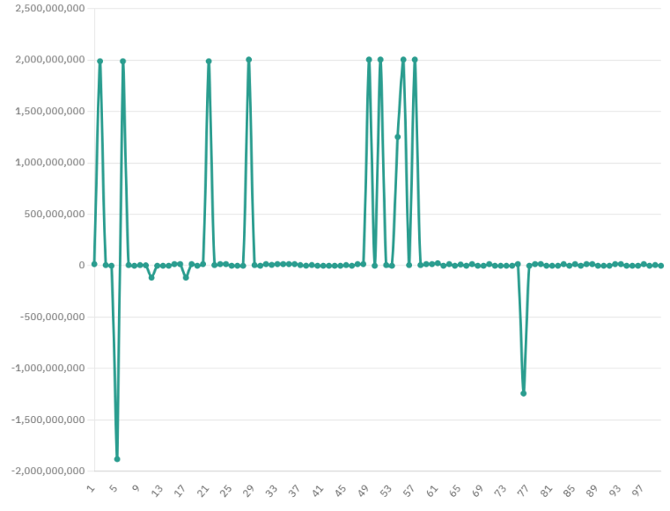

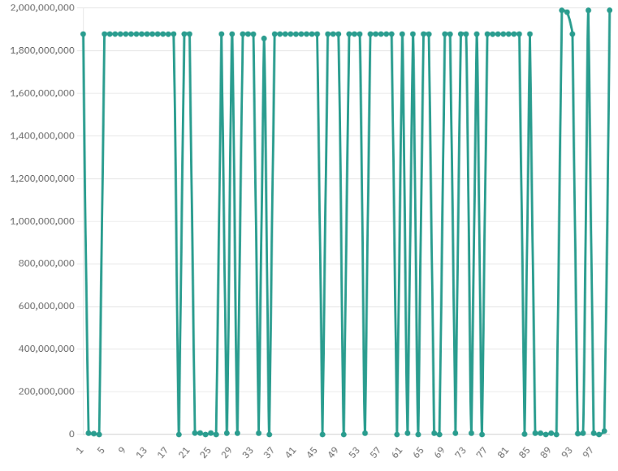

**4. Case Study**

***Case Study: The Impact of Uninitialized Variables on Program Stability and Security [Hypothetical]***

**4.1 Background**

A software application developed in C++ was observed to crash sporadically in its Release Mode but behaved predictably in Debug Mode. After extensive debugging, the issue was traced to an uninitialized variable, which occasionally contained random values, resulting in inconsistent behavior.

**4.2 Description of the Issue**

The application involved a function that managed a data structure responsible for tracking active user sessions. Within this function, a variable intended to track the status of a user session was declared but left uninitialized, as shown below:

void manageSession(UserSession session) {

int sessionStatus; // Uninitialized variable

//Conditional logic based on sessionStatus

if (sessionStatus == 1) {

// Perform actions for active session

} else {

// Perform actions for inactive session

}

}

When the sessionStatus variable was accessed before it was assigned an explicit value, it contained a random garbage value. This led to inconsistent behavior—sometimes the program treated the session as active, and at other times as inactive, depending on the garbage data present in sessionStatus.

**4.3 Compiler Behavior and Its Influence**

In **Debug Mode**, the compiler was configured to initialize uninitialized variables with a specific pattern (e.g., 0xCCCCCCCC) to detect uninitialized access easily. As a result, the application ran predictably during development, with errors surfacing only when sessionStatus was used before being initialized.

However, in **Release Mode**, optimizations were enabled to enhance performance. These optimizations included:

1. **Skipping Initialization**: In Release Mode, the compiler did not apply any pattern or default value to sessionStatus, leaving it to contain whatever data happened to be in the allocated memory.
2. **Register Allocation**: The compiler moved sessionStatus to a register to improve efficiency, which allowed the variable to pick up values from previous operations within the register, introducing further randomness.
3. **Stack Frame Reuse**: The compiler reused stack memory from previous functions for performance gains. Therefore, sessionStatus inherited values from prior stack frames, making the garbage value highly variable.

As a result, the application crashed intermittently in Release Mode, often only after prolonged use or under high loads, making the issue challenging to reproduce and diagnose.

**Analysis of Contributing Factors**

The unpredictability of sessionStatus was due to a combination of factors:

* **Previous Memory Contents**: The stack memory location assigned to sessionStatus often contained data from other variables, producing random results.
* **Optimization Decisions**: Compiler optimizations aimed at performance introduced random values to sessionStatus, as it skipped initialization and reused memory.
* **Platform Variability**: When tested on different processors, the behavior differed due to variations in register usage and stack management between architectures.

**4.4 Resolution**

The development team resolved the issue by explicitly initializing sessionStatus to a known value, ensuring predictable behavior across all environments and configurations:

int sessionStatus = 0;

// Initialized to inactive by default

**4.5 Lessons Learned**

This case highlighted several key lessons regarding uninitialized variables and compiler behavior:

1. **Initialize Variables by Default**: Explicitly initializing variables eliminates the possibility of garbage values and ensures stability.
2. **Compiler Differences**: Debug and Release Modes can introduce drastically different behavior. Testing in both configurations is essential to catch unpredictable behavior early.
3. **Optimization Awareness**: Developers should understand the potential impact of compiler optimizations on memory and variable initialization, particularly in performance-sensitive applications.

## 5. Conclusion

This study has demonstrated the inherent unpredictability of uninitialized variables and how various factors contribute to this randomness. Through analysis of memory allocation practices, compiler behavior, and code examples, it is clear that uninitialized variables produce values that are highly variable and undefined.

At the memory level, variables allocated on the stack and heap reflect the random remnants of data previously stored in those memory regions. When a stack variable is not initialized, it may contain leftover data from earlier computations, leading to values that can vary greatly each time the program is run. Similarly, dynamically allocated heap variables created with malloc start off with indeterminate values from the memory they occupy, which can shift unpredictably across different executions.

On the compiler level, optimization techniques introduce further variability. With optimizations enabled, the compiler may alter the code by removing or reshaping variable usage, making the outcomes of uninitialized variables even less predictable. Different compilers, and even different compiler versions or optimization flags, produce unique results, further amplifying the unpredictability of uninitialized values.

In summary, uninitialized variables are characterized by an underlying randomness, affected by the memory they occupy and the specific compiler handling them. This variability, demonstrated through both the code examples and graphical analysis, highlights how the state of uninitialized variables remains unpredictable and random in behavior, leading to outputs that are difficult, if not impossible, to foresee accurately.

The two ***graphs*** presented in this study illustrate the variability of garbage values produced by uninitialized variables when compiled with a single GCC compiler. The first graph depicts the distribution of garbage values obtained from 100 different uninitialized variables, highlighting the ***unpredictable nature*** of these values.

## 6. Reference

Understanding Undefined Behavior in C and C++

<https://en.cppreference.com/w/c/language/ub>

The Role of Compilers in Managing Uninitialized Variables

<https://gcc.gnu.org/onlinedocs/gcc/>

Memory Management in C and C++ In-depth documentation on how C and C++ manage memory, including stack and heap allocations.

<https://en.cppreference.com/w/c/memory>

Compiler Optimization Levels and Their Impact on Code Execution

<https://clang.llvm.org/docs/UsersManual.html>

Randomness in Uninitialized Variables  
Research articles that discuss the unpredictability of uninitialized memory in different computing environments.

<https://ieeexplore.ieee.org/>

Voltage Fluctuations and Hardware-Induced Errors in Memory

<https://ieeexplore.ieee.org/>

Electrical Noise and Memory Integrity  
Overview of environmental and electrical noise factors that may introduce random values into memory cells, particularly relevant in uninitialized memory contexts.  
<https://arxiv.org/>

## 

.